**The World (Avoid Asteroids Game)**

It is a game about a boy who got teleports into space from thin air. It is said that our universe is actually 11 dimension, space is 4 dimension, 3 normal directional axis and 4th one in space time. It is said there are a lot of gravity anomalies which happen in our space. Gravity can change space time. There is a myth about Bermuda triangle where gravity concentration is high so due to anomalies, stuff or even whole plan get teleported into unknown coordinate in the universe.

**Game Overview**

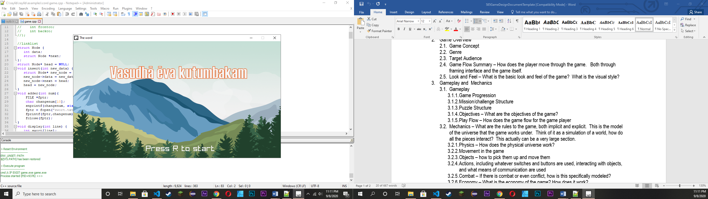

**Game Concept:**

It is about a boy on a school field trip. Whose bus suddenly get teleported into unknown corner of the universe and to survive he need to avoid getting hit by an asteroid.

**Genre:**

Classic Space Arcade game.

**Target Audience:**

Simple causal gamer.

**Game Flow Summary – How does the player move through the game. Both through framing interface and the game itself:**

After story player can just need to press “S” to start game. Player need to press Keyboard UP, Down, Right and left to control the bus.

The background music automatically start playing and so to stop it player can press “P” either pause or play the music.

**Gameplay and Mechanics:**

**Game Progression:**

Player just need to avoid asteroid and gain as much high score as possible.

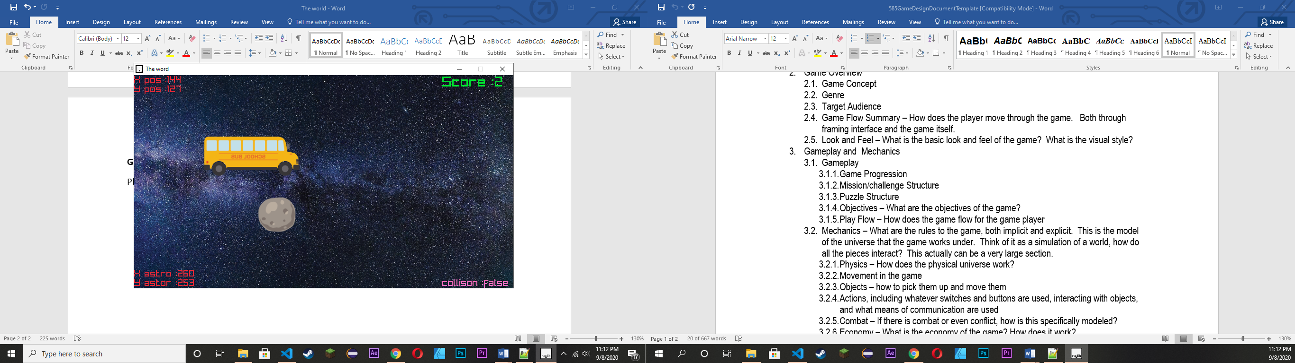

**Physic System:**

It is about a game in space so physic system is pretty straight forward. Player can move in this 2D space freely. For collision we draw a rectangle around both player and asteroid and when the two rectangle collide we pass true and the player die.

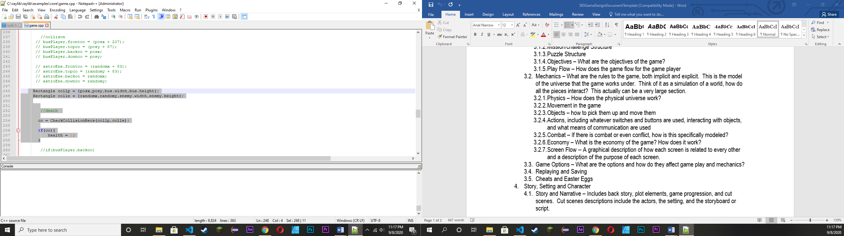

Player movement.

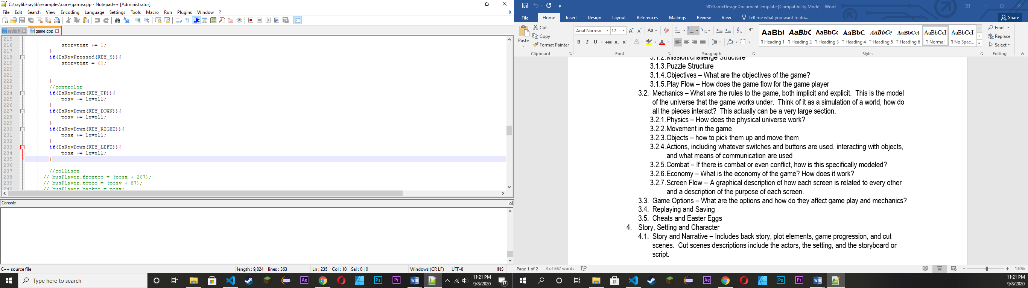

**Game Options:**

There are quit few option like

* “P” Key to pause and play background music.
* “H” Key to save your score in file.
* “S” Key to start game.
* “SPACE_BAR” Key to go to next page of the story.
* “M” Key to restart the game after you die.

**Saving:**

When you press “H” your score will automatically save in score.txt file.

